***Pattern Programs in Python***

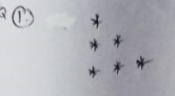

Sol:

for x in range(1,4):

for y in range(1,x+1):

print("*",end=" ")

print()

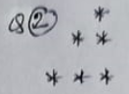

Sol:

for x in range(1,4):

for y in range(4,x,-1):

print(" ",end=" ")

for x in range(0,x):

print("*", end=" ")

print()

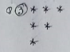

Sol:

for x in range(1,4):

for y in range(4,x,-1):

print("*", end=" ")

print()

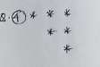

Sol:

for x in range(3,0,-1):

for y in range(x,4):

print(" ",end=" ")

for z in range(0,x):

print("*",end=" ")

print()

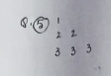

Sol:

for x in range(1,4):

for y in range(1,x+1):

print(x,end=" ")

print()



Sol:

for x in range(1,4):

for y in range(3,x,-1):

print(" ",end=" ")

for z in range(0,x):

print(x,end=" ")

print()

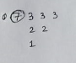

Sol:

for x in range(3,0,-1):

for y in range(1,x+1):

print(x,end= " ")

print()

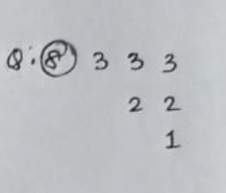

Sol:

"""

i = 0

for x in range(3,0,-1):

for z in range(1,i+1):

print(" ",end=" ")

for y in range(1,x+1):

print(x,end= " ")

i += 1

print()

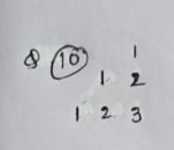

Sol:

for x in range(1,4):

for y in range(3,x,-1):

print(" ",end=" ")

for z in range(1,x+1):

print(z,end=" ")

print()

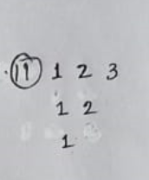

Sol:

for x in range(4,1,-1):

for y in range(1,x):

print(y,end=" ")

print()

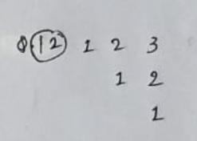

Sol:

for x in range(3,0,-1):

for y in range(x,3):

print(" ",end=" ")

for z in range(1,x+1):

print(z,end=" ")

print()

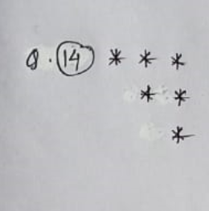

Sol:

for x in range(3,0,-1):

for y in range(x,3):

print(" ",end=" ")

for z in range(1,x+1):

print("*",end=" ")

print()

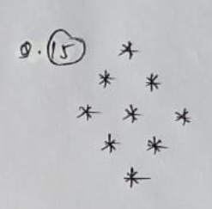

Sol:

size = 3

for x in range(size,-(size),-1):

for y in range(1,abs(x)+1):

print(" ",end=" ")

for z in range(size, abs(x), -1):

print("* ",end=" ")

print()

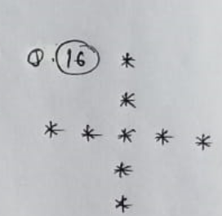

Sol:

n = 5

cen = n//2+1

for x in range(1,n+1):

for y in range(1,n+1):

if (x == cen or y == cen):

print("* ",end=" ")

else:

print(" " ,end=" ")

print()

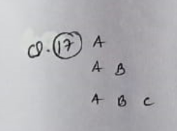

Sol:

for x in range(65,68):

for y in range(65,x+1):

print(chr(y),end= " ")

print()

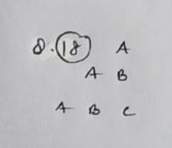

Sol:

for x in range(1,4):

for y in range(3,x,-1):

print(" ",end= " ")

for z in range(1,x+1):

print(chr(z+64),end=" ")

print()

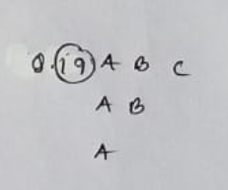

Sol:

for x in range(3,0,-1):

for y in range(0,x):

print(chr(y+65),end= " ")

print()

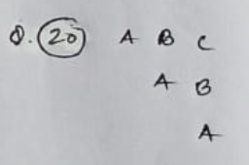

Sol:

for x in range(3,0,-1):

for y in range(x,3):

print(" " ,end= " ")

for z in range(0,x):

print(chr(z+65),end= " ")

print()